Supplementary data:
Table S1. Sequence of the primers
Gene name | Forward primers | Reverse primers | Basic Tm¹  (°C) | Ta²  (°C) | Ta  (°C) | cDNA (ng)
RPL32 | TGCTAAGCTGTCGCACAAATGGC | TGTTCGATCCGTAACCGATGTTGGG | F:57.1  R:59.3 | F: 58.79  R:59.45 | 57 | 50
Hook | CGCATTCTTTCCCTGTCGCAT | GGAGTGTCTTTTGTTCATTTAGC | F:54.4  R:51.7 | F: 54.13  R:53.32 | 59 | 75
Atg6 | GGAGTTATCTTTGCCCATC | TAGAGTCCGTAAGCCTGT | F:48.9  R:48.0 | F: 56.4  R:56.13 | 61 | 50
Atg8 | GGTGATTTGGACAAGAAGAAGTA | TCCTCGTGATGTTCCTGGTACGA | F:51.7  R:57.1 | F: 58.92  R:60.54 | 61 | 50
Cathepsin D | ATCATCGGTGGTCAGTATGT | AGAATATAGTCCTTGCCCTGC | F:49.7  R:52.4 | F: 55.17  R:56.05 | 61 | 50

- 45 cycles were applied for all primers
- Tm= 64.9 +41*(yG+zC-16.4)/(wA+xT+yG+zC)
- Ta of each primer: Ta = 0.3 x Tm(primer) + 0.7 Tm (product) – 14.9

Table S2. Bayesian hierarchical linear model estimations table for climibing assay based on the median of posterior sampling for each model parameters.
Model Parameters | n_eff |  | Rhat | mean | sd | HPD 2.5% | HPD  97.5%
(Intercept) | 4401 |  | 1 | 80.4 | 0.8 | 78.7 | 82
groupT406 | 5261 |  | 1 | 0.8 | 1.1 | -1.5 | 3.1
tm5 Days | 4848 |  | 1 | 13.6 | 1.2 | 11.2 | 15.8
group Aβ42: subgroupCross | 5092 |  | 1 | -34.8 | 1.2 | -37.1 | -32.4
group Tau R406W: subgroupCross | 6215 |  | 1 | -42.5 | 1.1 | -44.7 | -40.2
group Tau R406W:tm5 Days | 5550 |  | 1 | 1.2 | 1.6 | -2.1 | 4.5
group Aβ42: subgroupCross:tm5 Days | 5860 |  | 1 | 4.9 | 1.6 | 1.6 | 8.1
group Tau R406W: subgroupCross:tm5 Days | 7556 |  | 1 | 3 | 1.6 | -0.3 | 6.1
sigma | 2882 |  | 1 | 1.4 | 0.3 | 0.9 | 2.1
- * Highest posterior density (HPD) interval a Bayesian Credible Intervals that is estimated based on the quantile of Posterior distribution of each parameter.

Table S3. Independed-sample t-test out put for climbing assay
Flies types | Mean difference (control-cross) | P value | Standard Errors difference (control-cross) | Fold  change
Aβ42 5days | 29.67 | ≥0.001 | 0.53 | 0.32
Tau R406W 5 days | 39.59 | ≥0.001 | 1.23 | 0.42
Aβ42 25 days | 34.9 | ≥0.001 | 1.14 | 0.44
Tau R406W 25 days | 42.6 | ≥0.001 | 0.59 | 0.53
*p value less than 0.05, ** p value less than 0.01, *** p value less than 0.001

Figure S1: Significant decrease in the climbing ability was observed in 5 and 25-day old flies expressing Aβ42 or Tau R406W. *p value less than 0.05, ** p value less than 0.01, *** p value less than 0.001

Table S4. Bayesian hierarchical linear model estimations table for genes expression based on the median of posterior sampling for each model parameters.

Model Parameters | n_eff | Rhat | mean | sd | 2.5% | 97.5%
(Intercept) | 2215 | 1 | 1 | 0 | 0.9 | 1
group Tau R406W | 2111 | 1 | 0 | 0.1 | -0.1 | 0.2
tm5 Days | 2070 | 1 | 0 | 0.1 | -0.1 | 0.2
geneAtg8 | 2388 | 1 | 0.1 | 0.1 | 0 | 0.2
geneAtg6 | 2570 | 1 | 0 | 0.1 | -0.1 | 0.1
geneHook | 2408 | 1 | 0 | 0.1 | -0.1 | 0.2
group Aβ42: subgroupCross | 2337 | 1 | -0.7 | 0.1 | -0.8 | -0.6
group Tau R406W: subgroupCross | 2863 | 1 | -0.9 | 0.1 | -1 | -0.7
group Tau R406W: tm5 Days | 2001 | 1 | 0 | 0.1 | -0.2 | 0.1
group Tau R406W: geneAtg8 | 2431 | 1 | -0.1 | 0.1 | -0.2 | 0.1
group Tau R406W: geneAtg6 | 2464 | 1 | 0 | 0.1 | -0.2 | 0.1
group Tau R406W: geneHook | 2337 | 1 | 0 | 0.1 | -0.2 | 0.1
tm5 Days: geneAtg8 | 2365 | 1 | -0.1 | 0.1 | -0.2 | 0.1
tm5 Days: geneAtg6 | 2526 | 1 | 0 | 0.1 | -0.2 | 0.1
tm5 Days:geneHook | 2408 | 1 | -0.1 | 0.1 | -0.2 | 0.1
group Aβ42: subgroupCross:tm5 Days | 2109 | 1 | 0.6 | 0.1 | 0.5 | 0.8
group Tau R406W: subgroupCross:tm5 Days | 2800 | 1 | 2.1 | 0.1 | 1.9 | 2.2
group Aβ42: subgroupCross: geneAtg8 | 2624 | 1 | 0.2 | 0.1 | 0.1 | 0.4
group Tau R406W: subgroupCross: geneAtg8 | 3375 | 1 | 0.2 | 0.1 | 0 | 0.3
group Aβ42: subgroupCross: geneAtg6 | 2539 | 1 | 0.1 | 0.1 | 0 | 0.3
group Tau R406W: subgroupCross: geneAtg6 | 3493 | 1 | 0 | 0.1 | -0.1 | 0.2
group Aβ42: subgroupCross:geneHook | 2631 | 1 | 0 | 0.1 | -0.1 | 0.2
group Tau R406W: subgroupCross:geneHook | 3325 | 1 | 2.2 | 0.1 | 2.1 | 2.4
group Tau R406W: tm5 Days: geneAtg8 | 2446 | 1 | 0.1 | 0.1 | -0.2 | 0.3
group Tau R406W: tm5 Days: geneAtg6 | 2485 | 1 | 0 | 0.1 | -0.2 | 0.3
group Tau R406W: tm5 Days:geneHook | 2418 | 1 | 0 | 0.1 | -0.2 | 0.2
group Aβ42: subgroupCross:tm5 Days: geneAtg8 | 2403 | 1 | 2 | 0.1 | 1.8 | 2.2
group Tau R406W: subgroupCross:tm5 Days: geneAtg8 | 3325 | 1 | 3.9 | 0.1 | 3.6 | 4.1
group Aβ42: subgroupCross:tm5 Days: geneAtg6 | 2431 | 1 | 3.4 | 0.1 | 3.1 | 3.6
group Tau R406W: subgroupCross:tm5 Days: geneAtg6 | 3393 | 1 | 4.1 | 0.1 | 3.9 | 4.3
group Aβ42: subgroupCross:tm5 Days:geneHook | 2601 | 1 | -0.5 | 0.1 | -0.7 | -0.3
group Tau R406W: subgroupCross:tm5 Days:geneHook | 3224 | 1 | -3.4 | 0.1 | -3.6 | -3.2
sigma | 2528 | 1 | 0.1 | 0 | 0.1 | 0.1
mean_PPD | 10201 | 1 | 1.4 | 0 | 1.4 | 1.4
log-posterior | 1360 | 1 | 50.6 | 8.4 | 33 | 65.7

Table S5. Independed-sample t-test out put for the levels of Hook gene expression
Flies types | Mean difference (control-cross) | P value | Standard Errors difference (control-cross) | Fold  change
Aβ42 5days | 0.483 | 0.001 | 0.05 | 0.5
Tau R406W 5 days | -0.066 | 0.485 | 0.080 | 1.06
Aβ42 25 days | 0.583 | 0.002 | 0.078 | 0.59
Tau R406W 25 days | -1.24 | 0.018 | 0.174 | 2.26

Table S6. Independed-sample t-test out put for the levels of Atg6 gene expression
Flies types | Mean difference (control-cross) | P value | Standard Errors difference (control-cross) | Fold  change
Aβ42 5days | -3.41 | ≥0.001 | 0.090 | 4.45
Tau R406W 5 days | -5.35 | ≥0.001 | 0.082 | 6.31
Aβ42 25 days | 0.57 | ≥0.001 | 0.012 | 0.58
Tau R406W 25 days | 0.83 | ≥0.001 | 0.016 | 0.84

Table S7. Independed-sample t-test out put for the levels of Atg8 gene expression
Flies types | Mean difference (control-cross) | P value | Standard Errors difference (control-cross) | Fold  change
Aβ42 5days | -2.16 | ≥0.001 | 0.035 | 3.15
Tau R406W 5 days | -5.23 | ≥0.001 | 0.12 | 6.28
Aβ42 25 days | 0.45 | ≥0.001 | 0. 032 | 0.45
Tau R406W 25 days | 0.68 | ≥0.001 | 0.023 | 0.70

Table S8. Independed-sample t-test out put for the levels of Cathepsin D gene expression
Flies types | Mean difference (control-cross) | P value | Standard Errors difference (control-cross) | Fold  change
Aβ42 5days | 0.013 | 0.89 | 0.097 | 0.03
Tau R406W 5 days | -1.26 | 0.007 | 0.13 | 2.24
Aβ42 25 days | 0.68 | ≥0.001 | 0.026 | 0.74
Tau R406W 25 days | 0.84 | ≥0.001 | 0.03 | 0.85

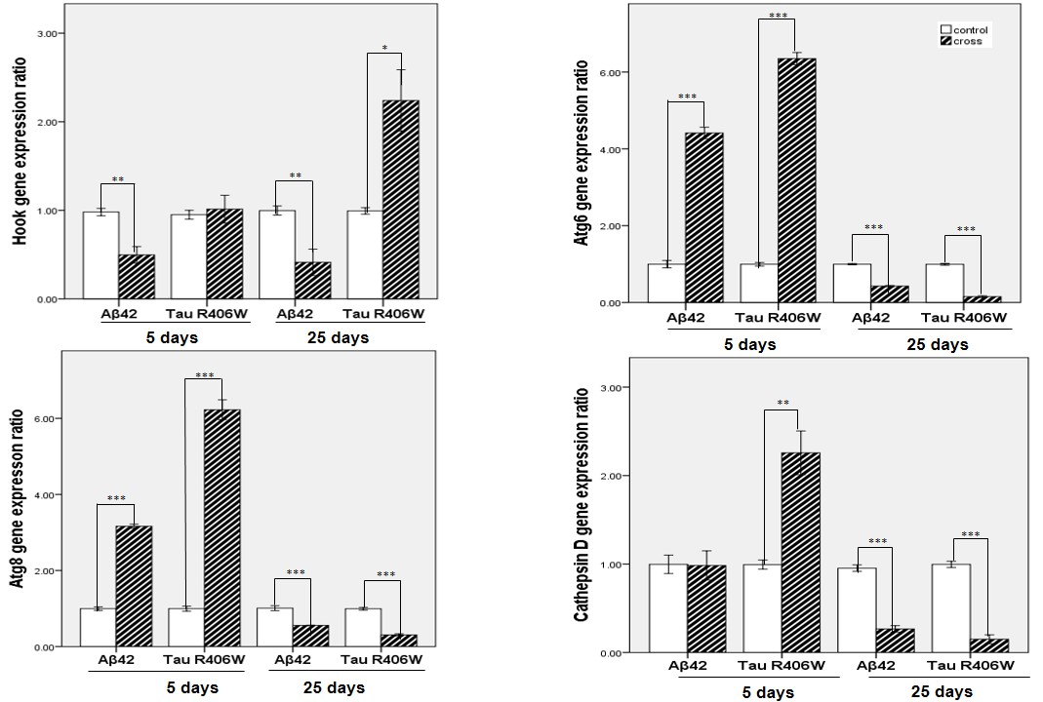

Figure S2: Fold change analysis for autophagy gene expressions in Aβ42 Tau R406W expressing flies. *p value less than 0.05, ** p value less than 0.01, *** p value less than 0.001

